Myositis Practice Case
Only can be used for XXXX
(© 2023 GuruKool LLC. All Rights Reserved)

CASE 1 (Dermatomyositis): Initial Presentation

A 46-year-old Caucasian female presented with complaints of fatigue and progressive muscle weakness in the proximal extremities (primarily in the arms and thighs) for the past 4 weeks. She felt tired and found it challenging to go about routine activities in the last few weeks. However, she did not report fever or weight loss. The weakness was profound and lately had increased to such an extent that she needed help for bathing and toileting.

In addition, she recently noticed a slight change in her voice and mild dysphagia with solid foods. She also complained of worsening dyspnea on exertion and non-productive cough for the last two weeks, but not requiring supplementary oxygen. She denies any joint pain or swelling but has mild myalgias. She did not report Raynaud’s, joint pain, and gastrointestinal symptoms; otherwise, the rest of the review of system was unrevealing.

Examination revealed several rashes developing in last 2-3 weeks, with an erythematous papules and cutaneous ulcer on the dorsum surface of the hands. She also has a mild to moderate red rash on the upper chest, upper back, as well as mild pink rash over both elbows with scales. Periungal erythema was observed with abnormal nail fold capillaries. Rest of the body areas were free of rashes and there is no hair loss. There was a bilateral late inspiratory crackle sound in the lung bases upon auscultation. Musculoskeletal examination confirmed profound proximal bilateral symmetric muscle weakness with the patient is only able to hold and sustain against gravity in iliopsoas and deltoid, able to hold against only mild pressure by the examiner in gluteus medius and maximus, mild to moderate pressure in neck flexor, moderate to strong pressure in neck extensors, biceps, triceps, quadriceps and hamstring, but the rest of the muscle and systemic examination showed no significant abnormalities.

Laboratory Investigations showed elevated CK (900 IU/L) and ferritin (1010 mcg/L). HRCT of the chest was suggestive of Interstitial Lung Disease (ILD) with bi-basal ground-glass opacities and linear reticulations suggestive of moderate Non-Specific Interstitial Pneumonia (NSIP) involving 25-50% of the lung fields scanned. EMG also showed evidence of myopathy; however, a muscle biopsy was not performed.

Representative Rash Images of Patient:

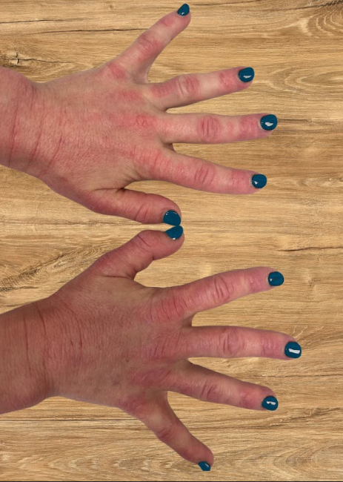
Dorsum of hand

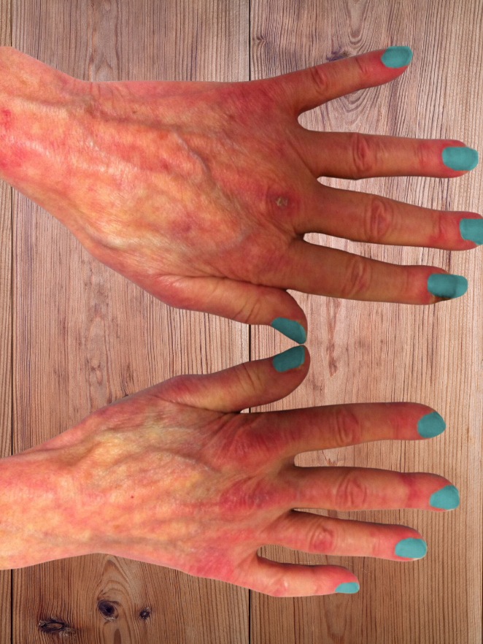
Cutaneous ulceration

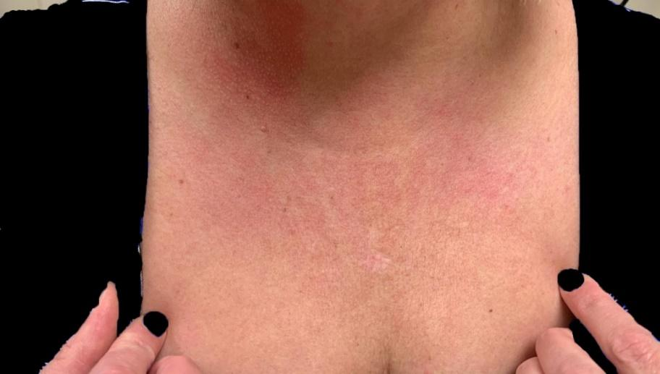
Upper chest (V area of neck)
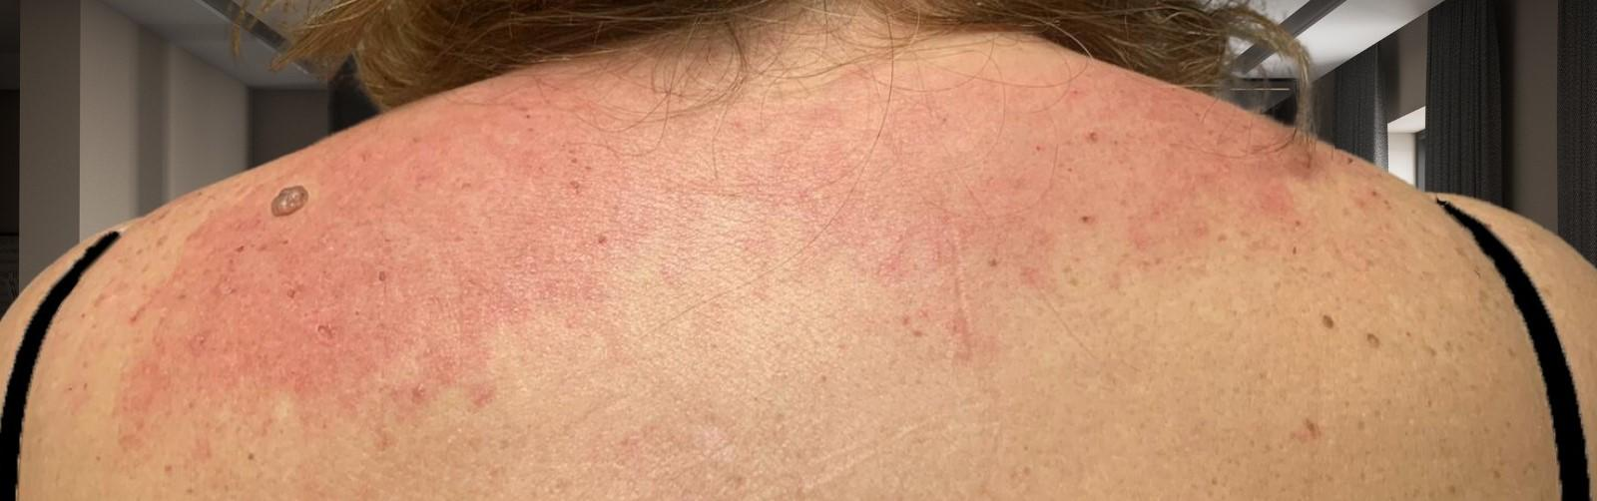
Posterior neck and upper back and shoulder

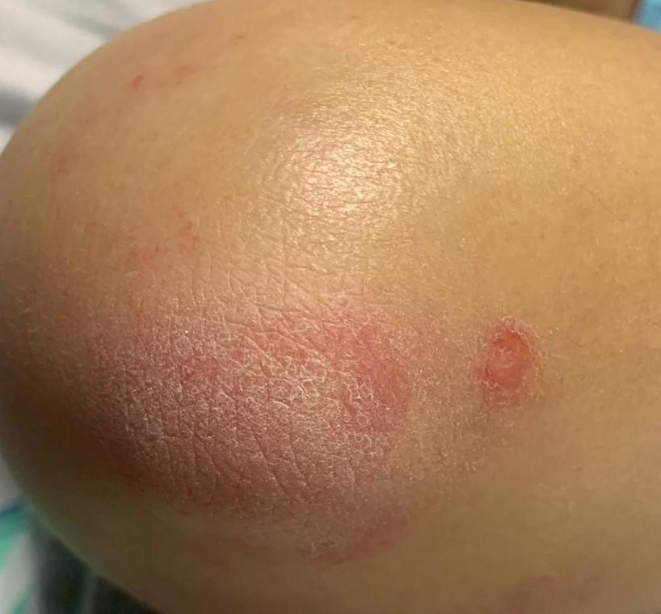
Elbow

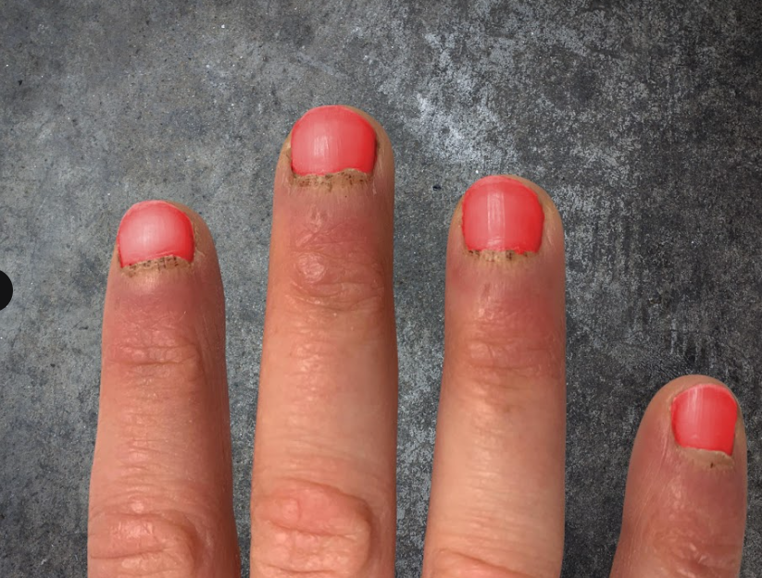
Periungal

CASE 1 (Dermatomyositis): Follow up visit

1 Month Follow up: The patient reports now reveal that the patient tested positive for anti-MDA5 antibodies. Therefore, cyclosporine, mycophenolate, and steroids were commenced for rapidly progressive ILD. She was followed up after 1 month and had moderate improvement in her muscle weakness. MMT-8 improved a lot, as well as her myalgia, and fatigue. She is able to carry out her daily activities with minimal support; however, her dyspnea and cough remained the same. Dysphonia and dysphagia have improved but yet not completely normal. Cutaneous rashes have started to heal but were still bothersome. She has no other new complaints.

On examination, all rashes have singificantly improved but present, with mild pink rash on the upper chest, upper back and neck. Mild pink non-palpable rash on back of her hands with no ulcerations, but no rash on elbows or knees. Periungal erythema remains the same. She does endorse new diffuse alopecia in the last month. MMT-8 examination reveals that the patient is able to hold against gravity with mild to moderate pressure in iliopsoas and deltoid, moderate pressure in gluteus medius and maximus, moderate to strong pressure in neck flexor and extensors, but the rest of the systemic examination showed no significant abnormalities.

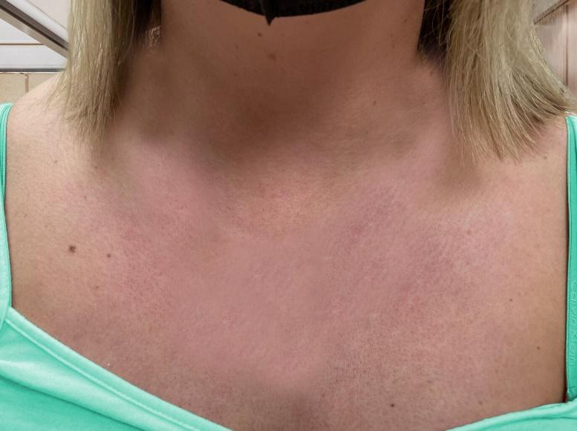
Upper chest

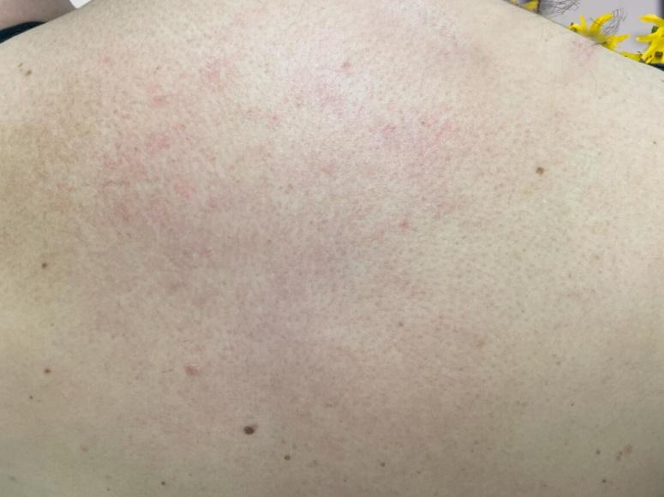
Upper back and neck
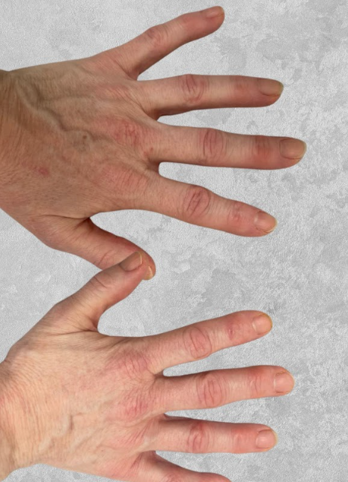
Dorsum of hand

Periungal changes

